**Internship Report**



A Internship Report Submitted to

Rajiv Gandhi Proudyogiki Vishwavidyalaya, Bhopal

Towards the partial fulfillment of the Degree of

**Bachelor of Engineering**

in

**Electronics and Telecommunication Engineering**

**Submitted to** Submitted by

**Prof. Shekhar Sharma** Vishal Sharma (0801EC211093)

**Prof. Shubham Shrivastava**

**Department of Electronics and Telecommunication Engineering**

**Shri G. S. Institute of Technology and Science Indore - 452003 (M.P.)**

**April 2025**

**Table of Contents**

Letter of Intent 3

Offer Letter 5

ACKNOWLEDGEMENT 8

PREFACE 9

INTRODUCTION TO COGNIZANT 10

INTRODUCTION TO IMS PROJECT 12

About the Inventory Management System Project 12

INTERNSHIP OVERVIEW 13

LEARNING AND CONTRIBUTIONS 14

TECHNOLOGIES USED 16

SKILLS GAINED 18

1. Understanding Spring Boot Framework 20

2. Designing REST APIs and Structuring the Backend 20

3. Database Integration and JPA Mapping 20

4. Version Control with GitHub 21

5. Writing Unit Test Cases 21

6. Managing Time During Project Deadlines 21

7. Containerization with Docker 21

8. Deployment on AWS 22

7. Implementing CI/CD Pipelines 22

CONCLUSION 23

# Letter of Intent

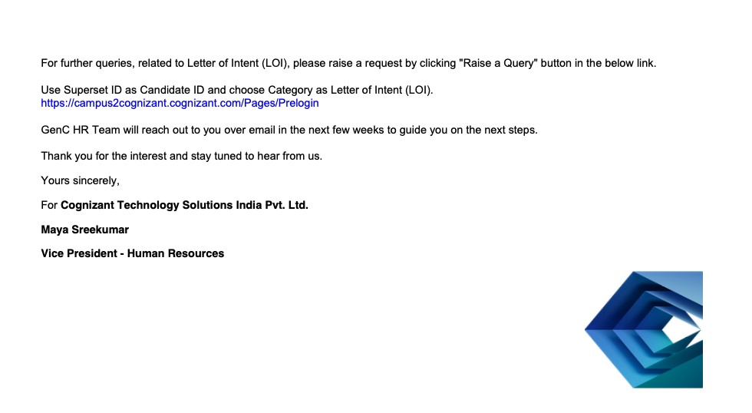

# Offer Letter

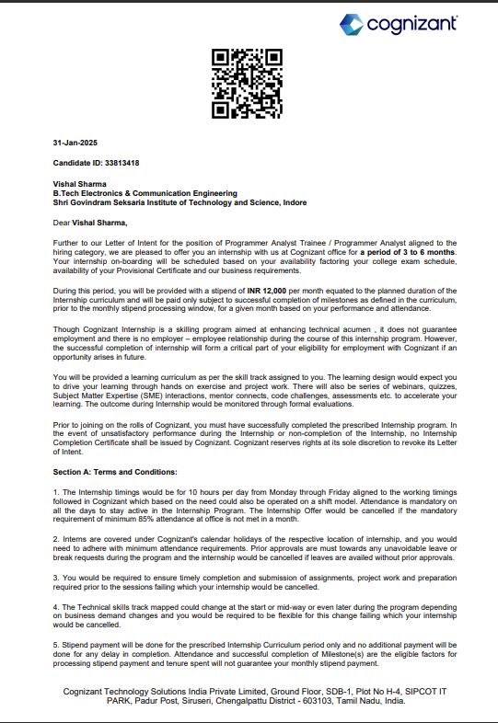

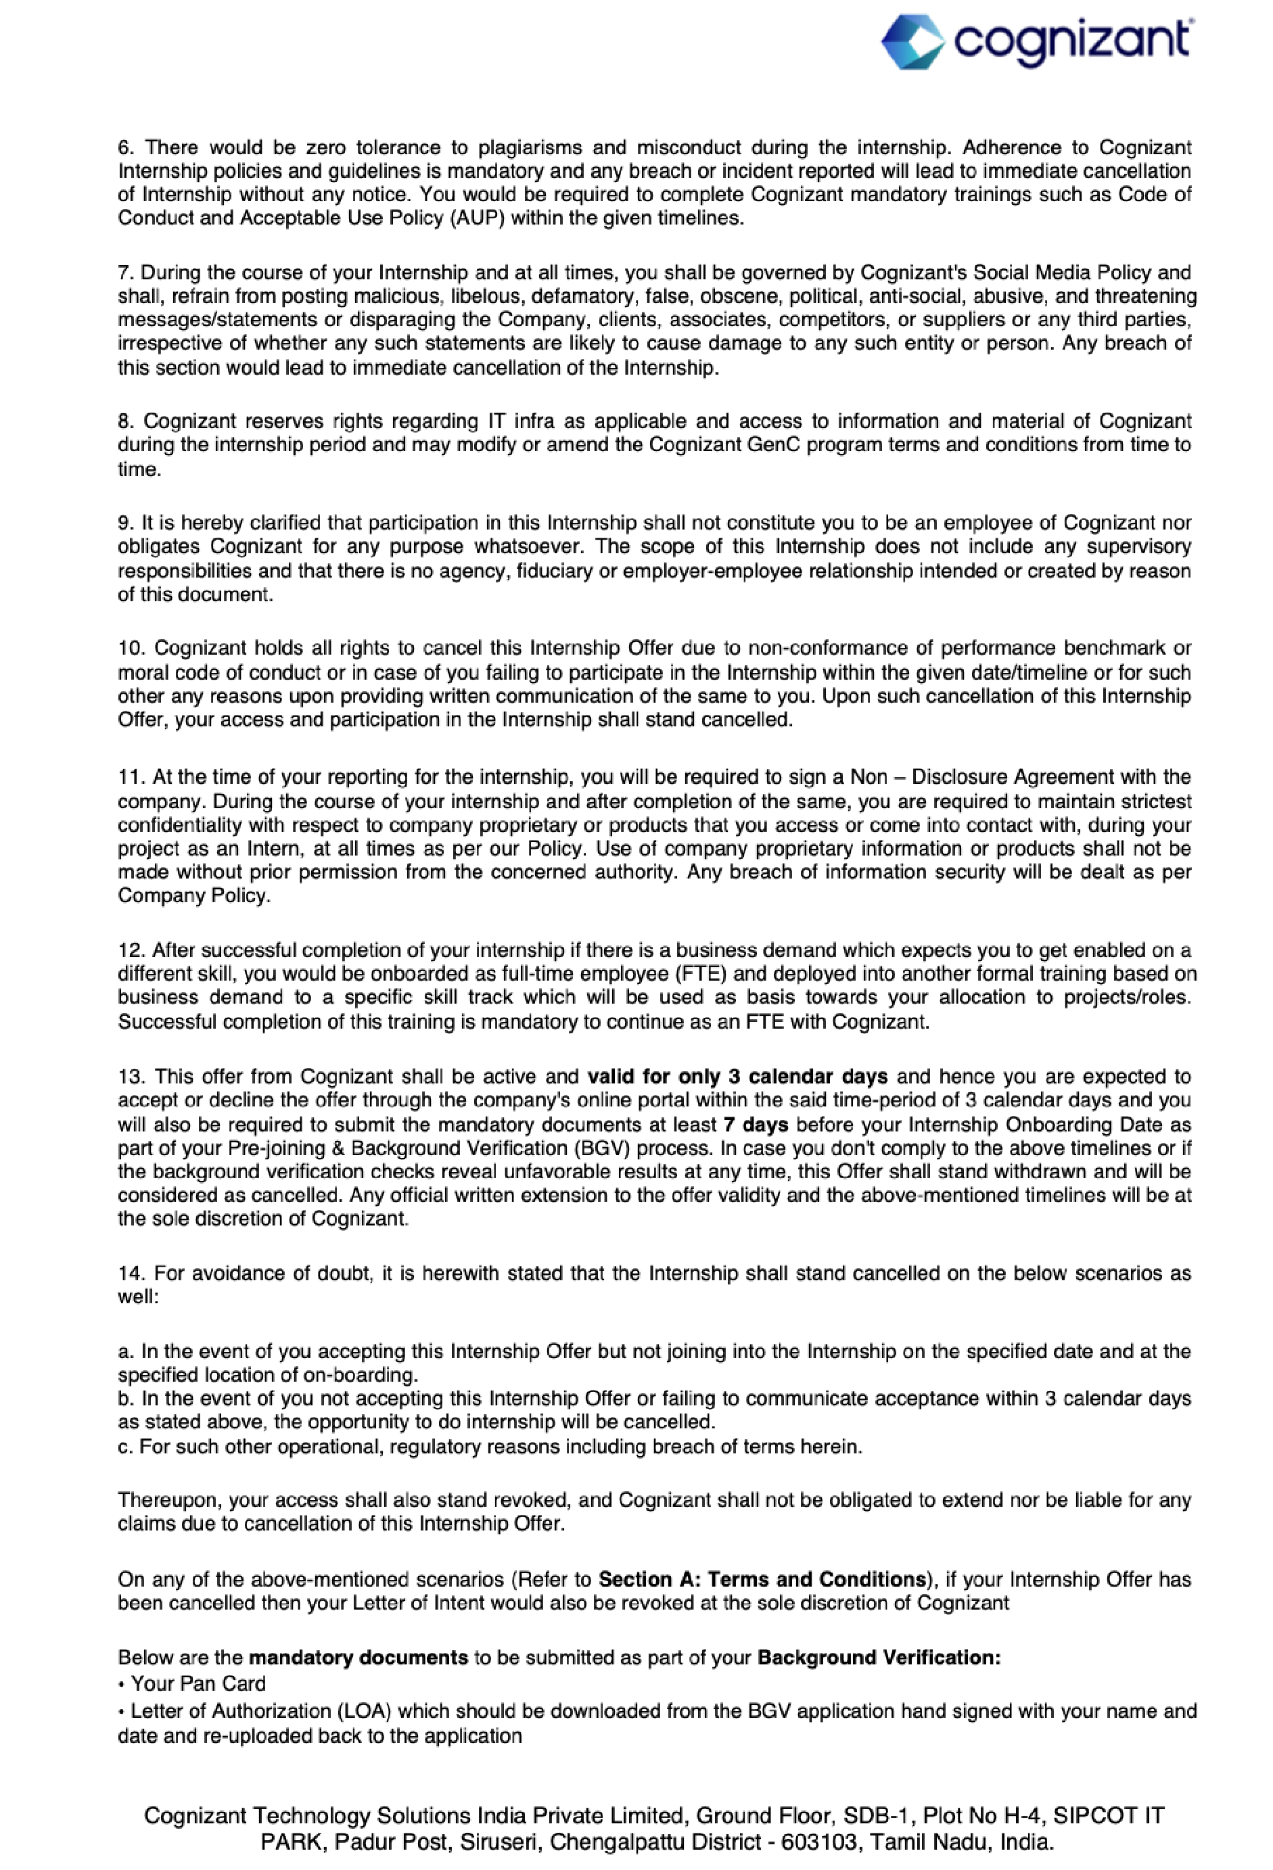

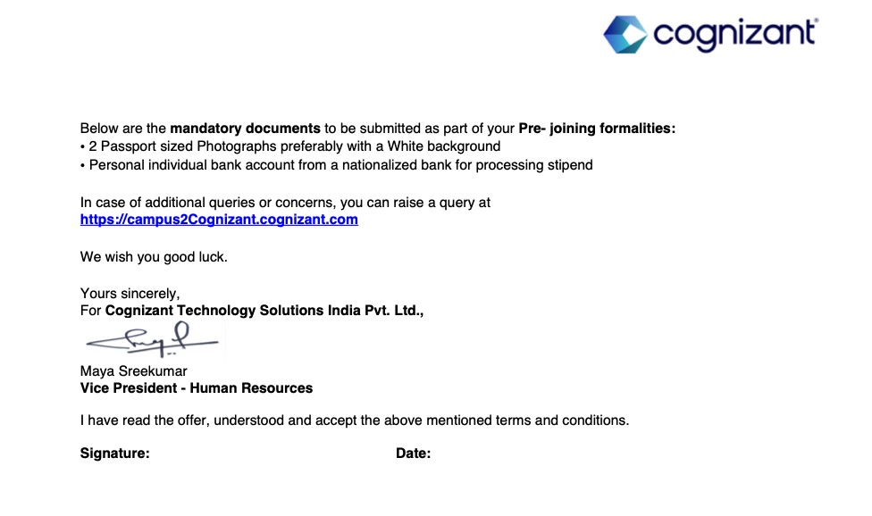

# ACKNOWLEDGEMENT

I take this opportunity to express my heartfelt gratitude to all those who have contributed to the successful completion of my internship at **Cognizant**.

First and foremost, I would like to extend my sincere thanks to **Shri G. S. Institute of Technology and Science (SGSITS), Indore** for providing me with the necessary academic foundation and support throughout my engineering journey.

I am deeply grateful to the **Department of Electronics and Telecommunication Engineering** for facilitating this industrial internship and helping me bridge the gap between theoretical knowledge and practical applications.

I would also like to express my gratitude towards the **Training and Placement Cell** of SGSITS Indore for their continuous efforts in creating excellent opportunities for students, including my selection at Cognizant for this internship program.

A very special thanks to **Cognizant** for giving me the platform to enhance my technical and professional skills through a real-world project.

I am highly thankful to my mentors and seniors at Cognizant for their continuous guidance, invaluable feedback, and unwavering support throughout the course of the internship. Their encouragement and constructive suggestions helped me learn and grow both technically and personally.

I wish to convey my deepest appreciation to my **faculty mentor** at SGSITS for their constant supervision, valuable insights, and encouragement which helped me stay focused and motivated throughout this period.

Lastly, I owe my deepest gratitude to my **family and friends** for their endless support, understanding, and motivation at every step, without which this journey would not have been possible.

This internship has been a truly enriching experience, and I am grateful to everyone who has directly or indirectly contributed to my learning and growth.

# PREFACE

Internships are a vital part of a student's academic journey, serving as a bridge between the theoretical knowledge acquired in classrooms and the practical challenges encountered in the real world. They not only provide exposure to industrial work culture but also help develop technical proficiency, soft skills, and a professional mindset essential for a successful career.

This report documents my internship experience at Cognizant, where I worked as a Programmer Analyst Trainee during the period from January 2025 to June 2025. The internship was undertaken as a part of the academic curriculum of Shri G. S. Institute of Technology and Science (SGSITS), Indore, under the Department of Electronics and Telecommunication Engineering.

During my tenure at Cognizant, I had the opportunity to develop an **Inventory Management System**. This project allowed me to gain hands-on experience with a variety of technologies, including **Spring** and **SpringBoot** for backend development, **Docker** and **Kubernetes** for containerization and deployment, and **AWS services** such as **EC2**, **RDS**, **S3**, and **DynamoDB**. I also enhanced my understanding of backend development, database integration, API creation, and basic unit testing using JUnit. Furthermore, I gained insights into the use of professional tools such as Maven for project management and Git for version control and collaboration.

The experience helped me develop not only my technical skills but also professional skills such as time management, teamwork, problem-solving, and adapting to a corporate environment. Working under the guidance of experienced mentors at Cognizant provided me with practical insights into project workflows, industry standards, and client-oriented thinking.

This report is a humble attempt to present a comprehensive overview of the tasks undertaken, the knowledge gained (including the technologies mentioned above), the challenges encountered, and the solutions implemented during my internship. It highlights the key learnings that I will carry forward into my professional career.

I hope this document will reflect the sincerity, dedication, and enthusiasm with which I approached my internship and serve as a testimony to the valuable experiences and skills I have acquired during this transformative period.

# INTRODUCTION TO COGNIZANT

**Cognizant** is a leading global provider of information technology, consulting, and business process outsourcing services. Headquartered in **Teaneck, New Jersey, USA**, Cognizant has established itself as one of the premier multinational companies specializing in digital transformation, helping clients adapt to the fast-evolving technological landscape.

### History and Growth

Cognizant was founded in **1994** as an in-house technology unit of Dun & Bradstreet. Recognizing the rising demand for IT services, it was spun off as an independent entity in **1996**. Since its inception, Cognizant has experienced exponential growth, becoming one of the first companies to be listed on NASDAQ-100 and entering the Fortune 500 list. Today, it ranks among the top global IT service companies, recognized for its consistent growth, innovation, and client-centric approach.

### Global Presence

Cognizant operates across **40+ countries** with a strong presence in **North America, Europe, Asia-Pacific, and Latin America**. With a global workforce of **over 350,000 employees**, Cognizant delivers consulting-led services and solutions that span industries such as **banking, healthcare, insurance, retail, manufacturing, communications, media, entertainment, and life sciences**.

The company's development centers and innovation hubs across India — particularly in cities like Chennai, Pune, Hyderabad, Bengaluru, and Kolkata — play a significant role in delivering world-class technology solutions.

### Areas of Expertise

Cognizant’s core service areas include:

* **Digital Business**: Helping clients transform their businesses with cloud, analytics, IoT, AI, and automation.
* **Technology Modernization**: Migrating legacy systems to modern platforms, cloud computing, and system integration.
* **Business Process Services**: Redesigning business processes using digital technologies to enhance agility and efficiency.
* **Consulting Services**: Offering strategic guidance to optimize operations, reduce costs, and foster innovation.

Cognizant places strong emphasis on **innovation, customer experience, operational excellence**, and **cutting-edge research** to stay ahead in a rapidly changing digital economy. **Culture and Values**

Cognizant promotes a strong work culture based on its core values:

* **Client First**: Prioritizing client success in every engagement.
* **Transparency and Integrity**: Maintaining ethical conduct and open communication.
* **Passion for Excellence**: Driving continuous improvement and quality delivery.
* **Empowerment and Inclusivity**: Encouraging diversity, collaboration, and leadership development at all levels.

Through its **corporate social responsibility** initiatives, Cognizant also invests in education, healthcare, environmental sustainability, and community development, reaffirming its commitment to social causes.

### Cognizant India

India remains a strategic hub for Cognizant’s operations, with a major part of its workforce and delivery capabilities cantered in the country. Cognizant India is recognized for providing highquality technology solutions, supporting global clients, fostering innovation, and contributing significantly to Cognizant’s leadership in the global IT services sector.

### Internship at Cognizant

Interning at Cognizant provides students and young professionals an opportunity to work on live projects, interact with experienced mentors, and get exposed to best practices in software development, project management, and client servicing. The company offers an excellent environment for learning emerging technologies, agile methodologies, and professional ethics, shaping interns into industry-ready professionals.

The internship program reflects Cognizant’s commitment to nurturing fresh talent and building the next generation of digital professionals.

# INTRODUCTION TO IMS PROJECT

As part of my internship at Cognizant, after undergoing initial technical and process training, I was assigned a project titled "Development of Inventory Management System".

Initially, the internship involved structured learning modules to build a strong foundation in Agile methodologies and DevOps tools. Understanding Agile processes such as Scrum, daily stand-ups, sprint planning, and retrospectives helped me appreciate the importance of iterative development, client feedback cycles, and team collaboration in real-world projects. Additionally, learning DevOps tools like Docker and Kubernetes enabled me to understand containerization, orchestration, and deployment strategies — essential skills for modern backend development and cloud deployment.

After successfully completing the learning phase, I was tasked with the practical development of an Inventory Management System using Spring Boot, an industry-standard Java-based framework for building scalable backend applications.

# About the Inventory Management System Project

An Inventory Management System is a software application designed for managing and tracking product stock levels, orders, and shipments, and for providing reports. It serves as a platform for optimizing inventory control, order processing, and warehouse management.

The objectives of the Inventory Management System project assigned to me were:

* To design and develop backend services to support product management, order processing, and stock functionalities.
* To implement CRUD operations (Create, Read, Update, Delete) for entities like Products, Orders, and Stock.
* To build REST APIs using Spring Boot following industry practices.
* To structure the application using MVC (Model-View-Controller) architecture.
* To integrate a database (MySQL) for storing product, order, and stock data.
* To deploy the application using Docker and AWS services.
* To follow Agile principles for incremental development and review.
* To apply basic unit testing principles using JUnit to ensure code quality.
* To use Maven for dependency management and Git for version control and collaboration.

This project provided me with an opportunity to apply the concepts learned during training in a real-world environment. It enhanced my understanding of backend system design, API development, database interactions, cloud deployment, and project management practices in an Agile framework.

The Inventory Management System project thus served as a vital part of my learning experience during the internship and helped me bridge the gap between theoretical learning and practical implementation.

# INTERNSHIP OVERVIEW

The internship program was structured to provide a comprehensive understanding of backend development, encompassing key technologies and tools. The program was divided into four distinct phases:

**Phase 1: Java Fundamentals**

The initial phase focused on establishing a strong foundation in Java programming. This included:

* Core Java concepts, including object-oriented programming principles.
* Data structures and algorithms.
* Java Standard Edition (Java SE) libraries.

**Phase 2: Advanced C and Unix**

This phase transitioned to lower-level programming and system concepts:

* Advanced C programming, covering memory management, pointers, and system-level programming.
* Unix operating system concepts, including file systems, shell scripting, and process management.
* This phase provided a deeper understanding of operating system interactions, crucial for efficient backend development.

**Phase 3: Spring, Spring Boot, and DevOps Tools**

The third phase introduced modern Java frameworks and DevOps practices:

* Spring Framework, including Dependency Injection and Aspect-Oriented Programming.
* Spring Boot, for rapid application development and microservices architecture.
* DevOps tools, specifically Docker and Kubernetes, for containerization, orchestration, and deployment.
* Exposure to AWS services, laying the groundwork for cloud deployment and scalability.

**Phase 4: Project Phase**

The final phase was dedicated to applying the acquired knowledge in a real-world project setting. This involved:

* Working on the "Development of Inventory Management System" project.
* Utilizing Spring Boot to build backend services.
* Employing Agile methodologies for project management.
* Deploying the application using Docker and AWS.

This structured approach ensured a gradual yet thorough learning curve, progressing from fundamental programming concepts to advanced framework utilization and cloud deployment. The internship provided a holistic experience in backend development.

# LEARNING AND CONTRIBUTIONS

During the course of my internship, I gained extensive technical knowledge, exposure to industry practices, and practical experience in software development. The journey was divided into two major aspects: learning new concepts and contributing to a real-world project.

**1. Learning Outcomes**

The initial part of my internship focused on building essential skills required for successful project execution. Key areas where I gained expertise include:

* **Agile Methodology:** I understood the principles of Agile development, Scrum ceremonies like daily stand-ups, sprint planning, retrospectives, and the importance of continuous delivery and feedback loops. Agile practices taught me to work collaboratively, meet incremental goals, and deliver quality outcomes within stipulated timelines.
* **Linux Fundamentals:** Learning Linux enhanced my confidence in using the command-line interface for basic file operations, user management, permissions, and server navigation — critical skills for backend development and deployment environments.
* **Spring Boot Framework:** I gained practical knowledge of Spring Boot, a popular Java-based framework for building scalable and robust web applications. I learned concepts like:
  + Setting up a Spring Boot project using Maven
  + Creating RESTful APIs
  + Building the application using MVC architecture
  + Integrating databases using Spring Data JPA
* **Version Control Systems (GitHub):** I learned the importance of source control in collaborative environments. I practiced:
  + Creating repositories
  + Making frequent commits
  + Managing code versions
  + Pushing and pulling code from remote repositories
* **Basic Unit Testing (JUnit):** I gained an introduction to writing unit tests using JUnit, ensuring the correctness and robustness of backend logic.
* **DevOps Practices and Tools:**
  + **Docker:** I learned to containerize applications, creating Dockerfiles and managing images and containers. This included understanding Docker Compose for multi-container applications.
  + **Kubernetes:** I gained knowledge of container orchestration using Kubernetes, including deploying and managing applications, scaling, and service discovery.
  + **AWS Services:** I was introduced to Amazon Web Services (AWS), including:
    - EC2 for virtual machines
    - S3 for storage
    - RDS for relational databases
    - DynamoDB for NoSQL databases
* **Deployment Strategies:** I explored various deployment strategies, such as blue/green deployments, and learned about CI/CD pipelines for automating the deployment process.

**2. Contributions to the Project**

After completing the learning modules, I actively contributed to the development of an Inventory Management System. My major contributions included:

* **Backend Development:** Developed RESTful APIs for Product Management, Order Processing, and Stock functionalities.
* **Database Integration:** Connected the application with a relational database (MySQL) for persistent data storage, performing CRUD operations.
* **API Documentation:** Created proper documentation for the REST APIs developed, enabling easy frontend integration and testing.
* **Project Management:** Used Maven to manage project dependencies and build configurations effectively.
* **Version Control:** Maintained the project codebase on Git, ensuring proper commit history and collaboration.
* **Testing:** Developed basic unit tests for critical service layer functions using JUnit to ensure application reliability.
* **Agile Participation:** Practiced Agile rituals including daily standups, sprint-wise task tracking, and periodic retrospectives under mentor guidance.
* **DevOps and Deployment:**
  + Containerized the application using Docker, creating Dockerfiles and optimizing images.
  + Deployed the application to AWS, utilizing services like EC2, S3, and RDS.
  + Implemented CI/CD pipelines using Jenkins to automate build, test, and deployment processes.
  + Contributed to defining and implementing deployment strategies, such as blue/green deployments, to minimize downtime.

# TECHNOLOGIES USED

During my internship at Cognizant, I had the opportunity to work with several modern tools and technologies. Learning and applying these technologies played a critical role in the successful development of the Inventory Management System project.

* **Spring Boot:** Spring Boot is a Java-based framework that simplifies the development of stand-alone, production-grade applications.

It allowed me to:

* + Rapidly set up backend services with minimal configuration.
  + Create RESTful APIs to handle product, order, and stock operations.
  + Implement the Model-View-Controller (MVC) design pattern effectively.
  + Integrate the application with relational databases using Spring Data JPA.

Its auto-configuration capabilities and embedded server support (like Tomcat) made backend development faster and more efficient.

* **Maven:** Maven is a build automation and dependency management tool used primarily for Java projects.

I used Maven to:

* + Manage project dependencies (e.g., Spring Boot libraries, database drivers).
  + Build and package the application.
  + Maintain a standardized project structure.

It helped automate many repetitive tasks, ensuring project consistency and simplifying builds.

* **Git:** Git is a distributed version control system that enables efficient tracking of changes and collaboration among developers.

During the project, I:

* + Maintained the source code repository.
  + Performed regular commits to track progress.
  + Managed different versions of the application safely.
  + Collaborated with other developers, including branching and merging.
  + Used platforms like GitHub for remote repository management and collaboration.
* **JUnit:** JUnit is a widely used testing framework for Java applications.

I learned to:

* + Write basic unit tests to validate backend service methods.
  + Perform early bug detection through test cases.
  + Understand the significance of maintaining code quality through automated testing.

Testing using JUnit improved the reliability and robustness of the application.

* **Linux:** Learning Linux fundamentals equipped me with:
  + Command-line skills for file management, directory navigation, and system operations.
  + Basic server operations required for backend project environments.
  + Understanding of user permissions, process management, and basic networking concepts.

Linux knowledge proved especially useful for development and deployment.

* **Agile Methodology:** The internship followed an Agile development model, where I practiced:
  + Dividing work into sprints.
  + Conducting daily stand-ups and periodic sprint reviews.
  + Delivering small, functional modules incrementally.
  + Embracing feedback-driven improvements.

Working in Agile helped me understand collaborative, iterative, and client-oriented development.

* **Docker:** Docker is a platform for developing, shipping, and running applications using containerization.

I used Docker to:

* + Containerize the Inventory Management System application.
  + Create Dockerfiles to define the application environment.
  + Manage Docker images and containers.
  + Use Docker Compose to define and manage multi-container applications.
* **Kubernetes:** Kubernetes is an open-source container orchestration system for automating application deployment, scaling, and management.

I utilized Kubernetes to:

* + Deploy and manage containerized applications.
  + Scale applications horizontally.
  + Perform rolling updates and rollbacks.
  + Manage application configurations and secrets.
* **AWS Services:** Amazon Web Services (AWS) is a cloud computing platform that provides a wide range of services.

I gained experience with:

* + EC2 (Elastic Compute Cloud) for deploying virtual machines.
  + S3 (Simple Storage Service) for storing application artifacts and data.
  + RDS (Relational Database Service) for managing relational databases.
  + DynamoDB for working with NoSQL databases.

# SKILLS GAINED

The internship at Cognizant offered me the opportunity to expand my technical knowledge, strengthen professional competencies, and understand corporate workflows. Through the combination of structured training and hands-on project work, I acquired a wide range of valuable skills.

**1. Technical Skills**

* **Backend Development:** Acquired practical experience in designing and developing backend services using the Spring Boot framework.
* **API Development:** Built and exposed RESTful APIs following standard best practices for modular, scalable software systems.
* **Database Management:** Gained proficiency in integrating relational databases (MySQL) using Spring Data JPA, performing CRUD operations, and designing efficient data models.
* **Linux Fundamentals:** Developed familiarity with the Linux operating system, including file handling, permissions management, and command-line operations.
* **Version Control with Git:** Practiced maintaining project repositories, committing code systematically, and understanding branch-based development processes using Git.
* **Unit Testing:** Understood the basics of writing unit test cases using JUnit to ensure code reliability and improve code quality.
* **Maven Usage:** Effectively used Maven for dependency management and project building in Java-based applications.
* **Containerization with Docker:** Gained hands-on experience in containerizing applications using Docker, creating Dockerfiles, managing images, and utilizing Docker Compose for multi-container setups.
* **Container Orchestration with Kubernetes:** Developed skills in deploying and managing containerized applications using Kubernetes, including scaling, service discovery, and configuration management.
* **Cloud Computing with AWS:** Acquired practical knowledge of working with Amazon Web Services (AWS), including:
  + Deploying and managing applications on EC2 instances.
  + Utilizing S3 for storage and data management.
  + Working with relational databases using RDS.
* **CI/CD Implementation:** Learned to implement Continuous Integration and Continuous Deployment (CI/CD) pipelines using tools like Jenkins to automate build, test, and deployment processes.
* **Deployment Strategies:** Understood and applied different deployment strategies, such as blue/green deployments, to minimize downtime and ensure smooth application updates.

**2. Professional and Workplace Skills**

* **Agile Methodology:** Experienced working in an Agile environment involving daily stand-ups, sprint-based task planning, and iterative delivery of project modules.
* **Time Management:** Learned to prioritize tasks, set goals within limited time frames, and meet project deadlines effectively.
* **Adaptability and Learning:** Adapted quickly to new tools, frameworks, and project demands, demonstrating flexibility in a dynamic work environment.
* **Team Communication:** Improved verbal and written communication skills through regular interaction with mentors and team members.
* **Documentation and Reporting:** Practiced maintaining clean code documentation and preparing periodic status updates, a vital part of professional project tracking.

**CHALLENGES FACED AND SOLUTIONS**

Throughout the course of the internship at **Cognizant**, I encountered several technical and nontechnical challenges. However, each challenge provided a valuable learning opportunity and helped me develop problem-solving skills essential for professional growth.

## 1. Understanding Spring Boot Framework

**Challenge**:

Initially, it was difficult to grasp the complete working of **Spring Boot**, particularly concepts like dependency injection, annotations, and application configuration.

**Solution**:

I systematically went through official documentation, referred to training resources provided by Cognizant, built small practice applications, and regularly sought clarification from mentors. Hands-on practice and incremental learning helped me gain confidence over time.

## 2. Designing REST APIs and Structuring the Backend

**Challenge**:

Creating RESTful APIs from scratch, structuring services, repositories, and controllers based on the **MVC architecture** was initially overwhelming.

**Solution**:

I started by understanding the problem domain clearly, broke down requirements into smaller modules, and focused on building basic working APIs first. Gradually, I refined the structure following best practices suggested by my mentors.

## 3. Database Integration and JPA Mapping

**Challenge**:

Establishing the connection between the Spring Boot application and relational databases (H2/MySQL) and correctly mapping entity relationships was a complex task at the beginning.

**Solution**:

I studied relational database concepts, practiced entity-relationship mapping using **Spring Data JPA**, and debugged queries systematically. Practical debugging helped me master the flow between the backend and database.

## 4. Version Control with GitHub

**Challenge**:

Initially, managing commits, handling Git errors, and understanding branching strategies was confusing.

**Solution**:

Through regular usage and practice, I became comfortable with common Git commands, version control workflows, and the importance of frequent commits with clear messages. I also learned to resolve minor merge conflicts independently.

## 5. Writing Unit Test Cases

**Challenge**:

As a beginner, writing **JUnit** test cases and understanding assertions, mocks, and test coverage was a new concept.

**Solution**:

I started by writing simple test cases for basic service methods and gradually improved by studying examples and mentor feedback. Over time, I was able to test service functionalities effectively.

## 6. Managing Time During Project Deadlines

**Challenge**:

Balancing learning new concepts and meeting project deliverables within tight sprint timelines was demanding.

**Solution**:

I followed Agile principles by breaking down tasks into smaller achievable goals, maintained a personal task tracker, and communicated proactively with mentors in case of any blockers. Prioritizing tasks effectively helped manage work within deadlines.

## 7. Containerization with Docker

* Challenge: Understanding Docker concepts, writing Dockerfiles, and managing containers effectively was challenging initially.
* Solution: I went through Docker documentation, practiced building Docker images, and running containers. I also worked on Docker Compose to manage multi-container applications, which helped me grasp the concepts.

## 8. Deployment on AWS

* Challenge: Deploying the application on AWS, configuring EC2 instances, setting up databases on RDS, and managing storage on S3 required a good understanding of cloud concepts.
* Solution: I followed AWS documentation, completed relevant AWS training modules, and sought help from mentors to understand the specifics of deploying a Spring Boot application on AWS.

## 7. Implementing CI/CD Pipelines

* Challenge: Setting up CI/CD pipelines using Jenkins to automate the build, test, and deployment process was complex and required a deep understanding of DevOps practices.
* Solution: I researched CI/CD concepts, learned Jenkins syntax, and worked closely with mentors to configure pipelines for the Inventory Management System project.

# CONCLUSION

The internship at Cognizant has been an enriching and transformative phase in my academic journey. It provided me with a valuable opportunity to bridge the gap between theoretical knowledge gained during my engineering studies and its practical application in a real-world corporate environment.

While the internship, I gained hands-on experience in a wide array of technologies and methodologies, including Agile methodologies, Linux fundamentals, backend development using Spring Boot, RESTful API creation, database integration, version control with Git, unit testing using JUnit, containerization with Docker, container orchestration with Kubernetes, and cloud computing with AWS. Each technology and process I learned contributed towards building a strong technical foundation and boosted my confidence in handling real-world software development and deployment challenges.

Working on the Inventory Management System project allowed me to apply the concepts learned during training in a structured and professional manner. It taught me not just the technical aspects of software engineering but also the importance of time management, code quality, collaborative working, and adherence to industry best practices, including DevOps principles for efficient deployment and scalability.

The internship also familiarized me with Agile work culture, project management techniques, and professional communication in a corporate setting, all of which are critical skills for a successful career in the IT industry.

I sincerely believe that the skills, exposure, and confidence gained during this internship, particularly in backend development, cloud technologies, and DevOps practices, will serve as a strong stepping stone towards my aspiration of becoming a competent and impactful software developer.

I am extremely thankful to Cognizant, my mentors, the Department of Electronics and Telecommunication Engineering, and SGSITS Indore for providing me with this valuable opportunity to grow both technically and professionally.